JANET PANIC

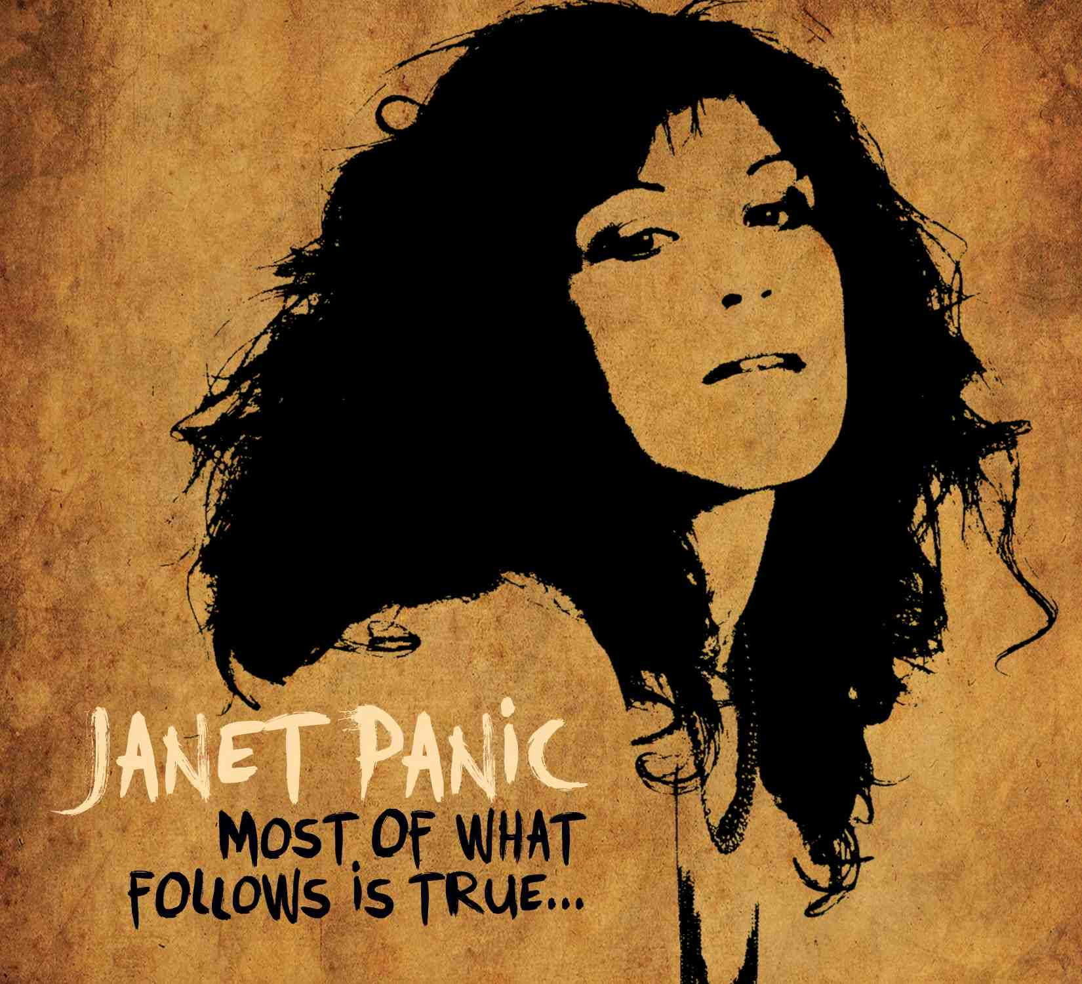

WHAT THE PRESS SAY…

“Her songs are drop-dead sexy." - Georgia Straight
"Panic has a great voice." - Calgary Herald
“She's a female cross between Lou Reed and Leonard Cohen." - Vancouver Sun
"Exceptionally catchy." - Vancouver Courier
“Entirely trippy pop music” – Westender

Artist Janet Panic writes beautifully crafted songs, from clever finger picking guitar melodies to cheeky turn of phrase. In the past 2 years her captivating solo/band performances have been seen on 4 telecasts on 3 different National networks: Global, CTV and APTN. Her music has attracted the attention of names such as Bruce Allen, Daniel Lanois and Ani DiFranco all the while expanding a dedicated fan base nationwide. Produced by Jeff Dawson (Dan Powter, Kelly Rowland, The Dudes, State Of Shock). Ms. Panic's new single, "Sweet Music” is the latest addition
to her delectable music storytelling. Call her music “essential pop”. This B.C. based singer/songwriter
has been casting her spell over an ever-expanding fan base on the strength of her great songs. She was nominated for
a 2011 Canadian Folk Music Award and for an Aboriginal People's Choice Award in 2011 and 2012. A polished and engaging performer, Ms. Panic is earthy and unpretentious – drawing you onto her stage with raw charisma. But at the end of the day, the thing you will remember is the songs – and her name. (And yes, that's her real name!) " Her New Album ,“Most of What Follows is True..." coming soon!

For more information please contact:
Radio: Last Tango Productions/Yvonne Valnea Tel: 416-538-1838 Email: info@lasttangoproductions.com

